Name: Aditya Gupta

Class: 12-J

Roll no.: 17

Computer science

Project: Hotel Management

Hotel management Program

{interface with sql}

Source Code

import mysql.connector as mycon

con=mycon.connect(host="localhost",user="root",passwd='432298')

cur=con.cursor()

cur.execute("create database hotel")

cur.execute("create table Room(Room_no varchar(30) primary key, grade_type varchar(50), status varchar(40),price int)")

cur.execute('create table customer(id int auto_increment primary key,name varchar(30),age int,contact int(20),check_in datetime default null,check_out datetime default null,room_no varchar(20) references Room(Room_no))')

print("Database formed successfully...")

cur.execute("use hotel")

def bookroom():

cur.execute('use hotel')

print("Please selct your room type-----")

print("Economy classs:1- Single room, non ac 2 residents max\n2-Platinum suite: AC Two rooms, 4 residents at max\n3-Diamond suite: AC, 2BHK 5 residents at max\n4:Special suite: 3 bedrooms,living rooom,balcony and private lift")

print("1-Room no..1- 20\n2- 21-40\n2- ...41-50")

ch=int(input("Enter your choice:"))

if ch==1:

print("Price for Economy suite is 2000 per day")

ch=input("Press Enter to Continue.....")

n=input("Enter Your Name")

a=int(input("Enter Your Age"))

c=int(input("Enter contact Number"))

r=int(input("Enter your room_no:"))

data=(n,a,c)

p=2000

t='Economy'

d=(r,t,p)

cur.execute("insert into Room(Room_no,grade_type,price) Values(%s,%s,%s);",d)

cur.execute('insert into customer(name,age,contact)values(%s,%s,%s);',data)

con.commit()

cur.execute("select Room_no from Room where grade_type='Economy' and status='Unreserved';")

cur.execute("select id from customer where name='{}' and contact={}".format(n,str(c)))

rec=cur.fetchall()

f=rec[0][0]

print(f)

con.commit()

elif ch==2:

print("Price for platinum suite is 3500 per day")

print("Proceeding for details:")

n=input("Please enter your name:")

a=int(input("Enter your age:"))

c=int(input("Enter contact number:"))

r=int(input("Enter Room no..:"))

data=(n,a,c)

p=3500

t='Platinum'

d=(r,t,p)

cur.execute("insert into Room(Room_no,grade_type,price) Values(%s,%s,%s);",d)

cur.execute('insert into customer(name,age,contact)Values(%s,%s,%s);',data)

con.commit()

cur.execute("select Room_no from Room where grade_type='Platinum' and status='Unreserved';")

cur.execute("select id from customer where name='{}' and contact={}".format(n,str(c)))

rec=cur.fetchall()

f=rec[0][0]

print(f)

con.commit()

elif ch==3:

print("Price for platinum suite is 4500 per day")

print("Proceeding for details:")

n=input("Please enter your name:")

a=int(input("Enter your age:"))

c=int(input("Enter contact number:"))

r=int(input("Enter your room_no:"))

data=(n,a,c)

p=4500

t='Diamond'

d=(r,t,p)

cur.execute("insert into Room(Room_no,grade_type,price) Values(%s,%s,%s);",d)

cur.execute('insert into customer(name,age,contact)Values(%s,%s,%s);',data)

con.commit()

cur.execute("select Room_no from Room where grade_type='Diamond' and status='Unreserved';")

cur.execute("select id from customer where name='{}' and contact={}".format(n,str(c)))

rec=cur.fetchall()

f=rec[0][0]

print(f)

con.commit()

elif ch==4:

print("Price for Special suite is 5200 per day")

print("Proceeding for details:")

n=input("Please enter your name:")

a=int(input("Enter your age:"))

c=int(input("Enter contact number:"))

r=int(input("Enter your room_no:"))

data=(n,a,c)

p=5200

t='Special'

d=(r,t,p)

cur.execute("insert into Room(Room_no,grade_type,price) Values(%s,%s,%s);",d)

cur.execute('insert into customer(name,age,contact)Values(%s,%s,%s);',data)

con.commit()

cur.execute("select Room_no from Room where grade_type='Special' and status='Unreserved';")

cur.execute("select id from customer where name='{}' and contact={}".format(n,str(c)))

rec=cur.fetchall()

f=rec[0][0]

print(f)

con.commit()

def check_in():

cur.execute('use hotel')

i=int(input("Enter id:"))

r=int(input("Enter your room_no:"))

stmt2="update customer set check_in=sysdate(),Room_no="+str(r)+" where id="+str(i)+";"

cur.execute(stmt2)

stmt3="update Room set status='Occupied' where Room_no={}".format(str(r))

cur.execute(stmt3)

con.commit()

def check_out():

cur.execute("Use hotel;")

i=int(input("Enter your id:"))

r=int(input("Enter your Room no"))

stmt4="update customer set check_out=sysdate() where id="+str(i)+";"

cur.execute(stmt4)

con.commit()

stmt5="Select Date(check_in),Date(check_out) from customer where id="+str(i)+";"

cur.execute(stmt5)

d=cur.fetchall()

t=d[0][-1]

q=d[-1][-1]

print("Check in date:",t,"\t\tCheck out date",q)

m=int(input("Enter number of days of stay:"))

stmt6="select price from Room where Room_no="+str(r)+";"

cur.execute(stmt6)

rec=cur.fetchone()

x=rec[-1]

print("Total staying cost in rupees:",x*m)

def customer_list():

cur.execute('use hotel')

cur.execute('select *from customer')

rec=cur.fetchall()

for i in range(0,len(rec)):

print(rec[i])

def customer_details():

cur.execute('Use hotel')

i=int(input("Enter custom id:"))

cur.execute("Select *from customer where id="+str(i)+";")

rec=cur.fetchall()

print(rec)

print("Name:",rec[0][1],"Age",rec[0][2],"Contact",rec[0][3],"Check-In Date",rec[0][4],"Checkout date",rec[0][5],"Room No",rec[0][6])

def main():

while True:

print("\t\t\tWelcome to Hotel Blue")

print()

print("\t\t\tMain menu:")

print("\t1-Book a roomm\n\t2-Check in \n\t3-Check out and billing\n\t4-View customer's list\n\t5-Cjeck customers details\n\t6-Quit")

print()

c=int(input("Enter your choice:"))

if c==1:

bookroom()

elif c==2:

check_in()

elif c==3:

check_out()

elif c==4:

customer_list()

elif c==5:

customer_details()

elif c==6:

break

else:

print("Please Enter a valid choice")

main()

Output page

1--Book a room:

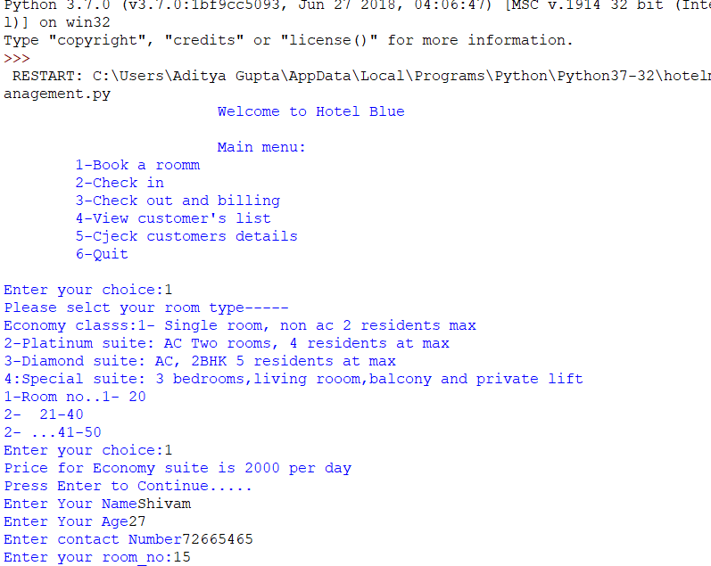

2--Checking in inside the Hotel:



3--Checking Out inside the Hotel:

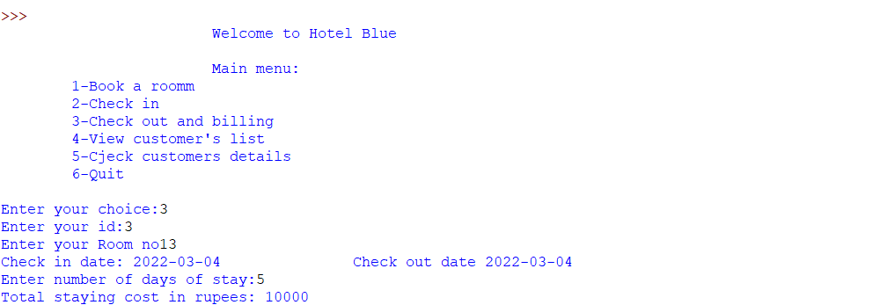

4—Checking customer list:

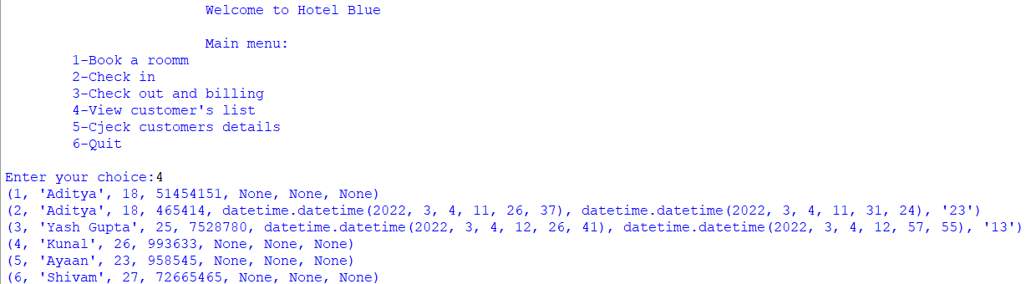

5—Checking customer Details:

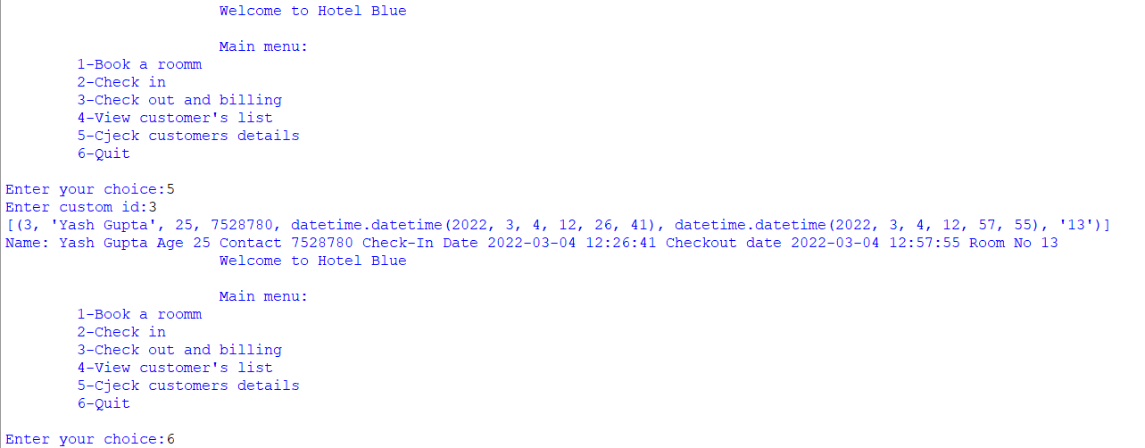

Bibliography

Computer science with python

{class 12} by Sumita Arora